DMS Assignment 3
I created two separate projects for my loosely coupled components. I have created a system for company to use where they have employees carrying out jobs and a people assigning jobs. I have used JMS queues as one side produces job and the other side consumes jobs. Jax-b types are utilised as POJOs are passed around the queue by first converting them into xml. I have created two types of messages that can be sent, a normal job and a high priority job, both get sent to different queues.

Here are the UML schemes for each package used
DMSJobConsumer-ejb.Beans
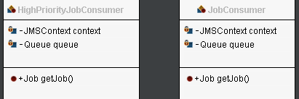
DMSJobProducer-ejb.Beans
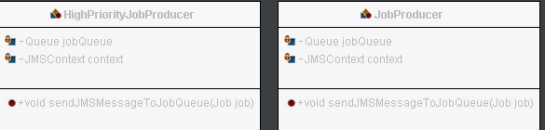
DMSJobProducer-ejb.Jobs
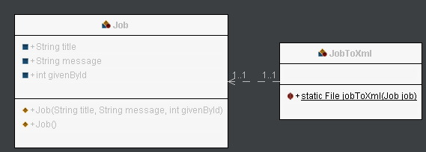

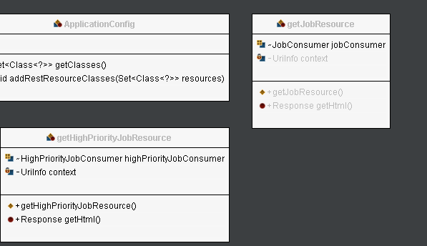
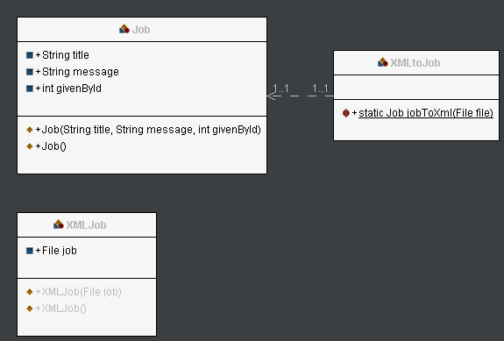
DMSJobConsumer-ejb.Job

DMSJobConsumer-war.RESTfulConsume

DMSJobProducer-war.RESTfulProduce
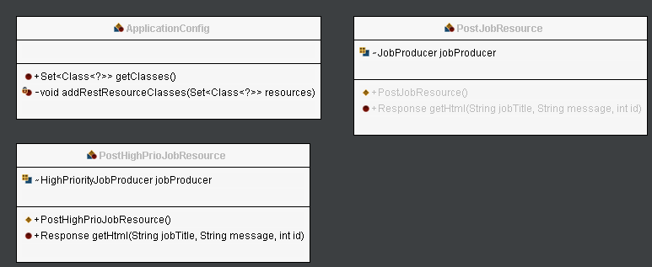
For the DMSProducer project the index page gives two options, send a normal job or a high priority job. Employees carrying out jobs are told to check for high priority jobs before going for a normal job. Each job contains three values. A job title, giving a brief description of the job. A job message, describing what the job entails. And the employee id of the person giving the jobs.

For the DMSConsumer project the index page gives two buttons, one to get a high priority job, and one to get a normal job. The page will send employees to one of two pages, displayJob if a job is returned, and jobNotFound if a job isn’t returned in 1 second.

